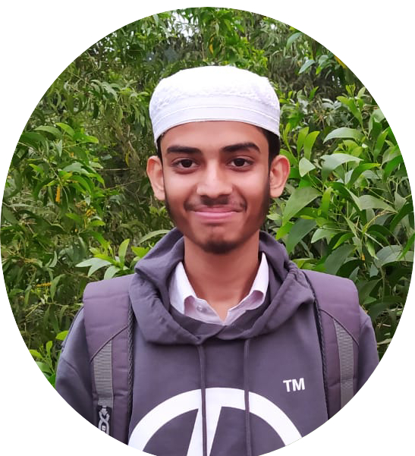

# CONTACT

📧 [**syednazmusshakib94@gmail.com**](mailto:syednazmusshakib94@gmail.com)

📞 [**+8801401997130**](tel:+8801401997130)

Sex: Male  
Date of Birth: 12/09/2004

Bangladesh,Sylhet,Habiganj.

# SKILL

* **HTML,CSS,BOOTSTRP,JAVASCRIPT,C,C++,DATASTRUCTURE,GITHUB,ALGORITHM,PYTHON,TAILWIND,REACT.JS**

## LANGUAGE

* English
* Bangla

# Shakib

## Programmer & SoftWere Developer.

## I started my programming journey with C and solved some problems, then learned C++ and solved some problems and did some projects with HTML, CSS, Bootstrap and JavaScript. Also I learned Python Java, PHP. Learned Data Structure Algorithms and solved these related problems.

## WORK EXPERIENCE

* Html Css Bootstrap Frontend Project
* Django,JavaScript Backend Project
* Problem Solving DataStructure & Algorithm C++ Language

### EDUCATION

#### Habiganj Polytechnic Institute:-

2022-2025

In this college I am  
studying Diploma in Engineering, CST.

1. 1st Semister CGPA->3.25 Out Of 4
2. 2st Semister CGPA->2.65 Out Of 4
3. 3st Semister CGPA->2.94 Out Of 4

#### Habiganj Technical School & College:-

2019-2021

I attended this ‍School in class nine and class ten, welding and fabrication trade.

CGPA->4.25 Out Of 5

#### Habiganj High Schoo:-l

2018

In this college I studied class eight in C branch.

CGPA-> 3.00 Out Of 5